CTM-I Test Plan

Login: Login

Version 0.1

Menu Tab: Login

Use Case Name | Login
User Roles | Firm User (CTMI_Firm_Options_Admin, CTMI_Firm_Options_Admin, CTMI_Firm_Options_Clerk, CTMI_Firm_Options_Broker), Market Ops (CTMI_Help_Desk), Ops (CTMI_Systems), App Support (CTMI_Root)
Pre-conditions /Assumptions | User has launched CTM-I application by pointing the browser to the correct URL and Login screen is displayed
Post Conditions | None
Screenshot | 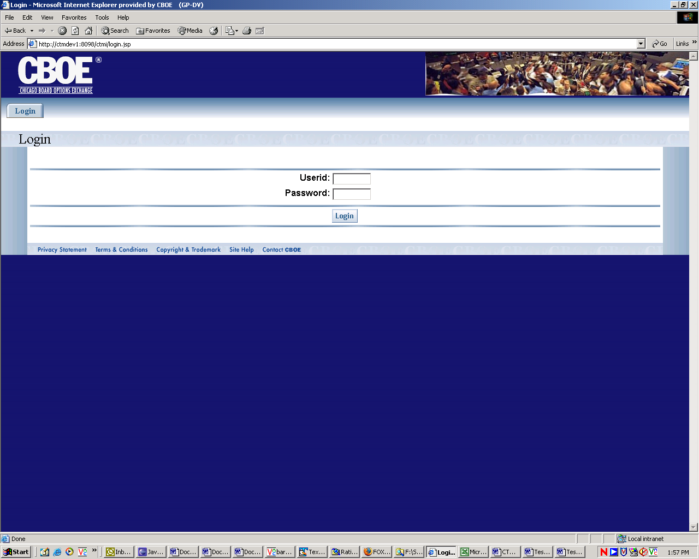
Test Scenario A | User Role : CTMI_Firm_Options_Root, User Id: xxx Password: xxx
 | Action | Expected Out Come | Comments/Results
Test Case 1  Successful Logon | User enters User Id and Password in the designated field and clicks on ‘Login’ button | Welcome Screen is Displayed with the following Menu Tabs  - Trade Query  - Firm Maintenance  - Security
Test Scenario B | Repeat above test cases with login with diff user roles namely Ops (CTMI_Firm_Options_Admin)  User Id: xxx Password: xxx
Test Case 1  Successful Logon | User successfully Logs In with given User Id and Password | User Sees the Welcome Page with the following Menu tabs.  - Trade Query  - Firm Maintenance  - Security
Test Scenario C | Repeat above test cases with login with diff user roles namely Ops (CTMI_Firm_Options_Clerk)  User Id: xxx Password: xxx
Test Case 1  Successful Logon | User successfully Logs In with given User Id and Password | User Sees the Welcome Page with the following Menu tabs.  - Trade Query  - Firm Maintenance
Test Scenario D | Repeat above test cases with login with diff user roles namely Ops (CTMI_Firm_Options_Broker)  User Id: xxx Password: xxx
Test Case 1
Successful Logon
Test Scenario E | Repeat above test cases with login with diff user roles namely AppSupport (CTMI_Root)  User Id: xxx Password: xxx
Test Case 1  Successful Logon | User successfully Logs In with given User Id and Password | User Sees the Welcome Page with the following Menu tabs.  - Trade Query  - Firm Maintenance  - Batch Utilities  - RTC  - Matching  - App Support  - Security  - Tests
Test Scenario F | Repeat above test cases with login with diff user roles namely AppSupport (CTMI_Systems)  User Id: xxx Password: xxx
Test Case 1  Successful Logon | User successfully Logs In with given User Id and Password | User Sees the Welcome Page with the following Menu tabs.  - Trade Query  - Firm Maintenance  - Batch Utilities  - RTC  - Matching  - App Support
Test Scenario G | Repeat above test cases with login with diff user roles namely AppSupport (CTMI_Help_Desk)  User Id: xxx Password: xxx
Test Case 1  Successful Logon | User successfully Logs In with given User Id and Password | User Sees the Welcome Page with the following Menu tabs.  - Trade Query  - Firm Maintenance  - Batch Utilities  - RTC  - Matching  - App Support  - Security  - Tests
Test Case 2  Login Fail | User enters userid and password on the Login Screen and clicks on ‘Login’ button | Login Failed. Invalid Login id / password error message appears with login screen displayed | Alternate Flow
Test Case 3  Max Retry (3 times) | User Enters invalid userid/password more than 3 times. | User should be locked out of the system with appropriate error message saying ‘Exceeded Max No of tries, being locked out of the system. Contact System Admin for help’ | This functionality is not there currently. Bruce pointed this out and asked should we need to have this feature. To be discussed with Eddie.  TBD

